

# 

COMPLAINT : 2

DATE: 19/Feb/2021

The Manager,

Bank Al Habib Ltd,

sample Branch,sample Zone

Subject: Quotation of subject_line.

Number of AC: 1

|  |  |  |  |  |
| --- | --- | --- | --- | --- |
| Sr. | Job Description | Qty | Rate | Amount |
|  | PCB kit Repair with aeroflex installation outdoor | 45rft | 2000 | 20000 |
|  | Gas charging | 45rft | 2000 | 23445.78 |
|  | Total |  |  |  |
|  | Tax 16% |  |  |  |
|  | Total |  |  |  |

**Yours truly,**

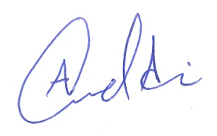 **ECO ENTERPRISES**